**Data Validation Tool**

**Manual**

**Written By: Eros Niko Cas Alvarez**

**Created On: September 15, 2016**

**Table of Contents:**

Topic Page

1. Table of Contents 1
2. What is Data Validation? 2
3. Introduction of Data Validation tool 2
4. How to Use 4
5. Message Prompts and Solutions 5

**What is Data Validation?**

Data Validation is the tool that ensures the legitimacy of data before it is ready to be imported to databases. Without this, the risk of failure to importing of data is high. Therefore, the vulnerability of database is also affected.

**Introduction of Data Validation Tool**

Data Validation tool consists of 3 modules: the Excel Data Validation, Creating Mappings, and Advanced Mapping Settings.

1. **Excel Data Validation –** it is the tool that is responsible for validating data from its *source*. It requires *source* and *map* excel file for validation.
   1. Source – Where the data are stored and used as import file for other applications
   2. 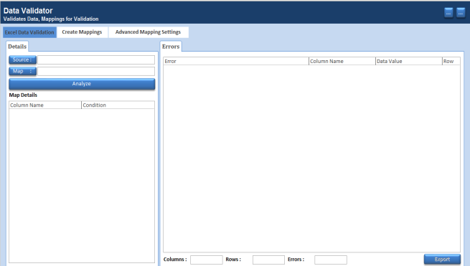Map – Where the validation conditions and column names from source are located.
2. 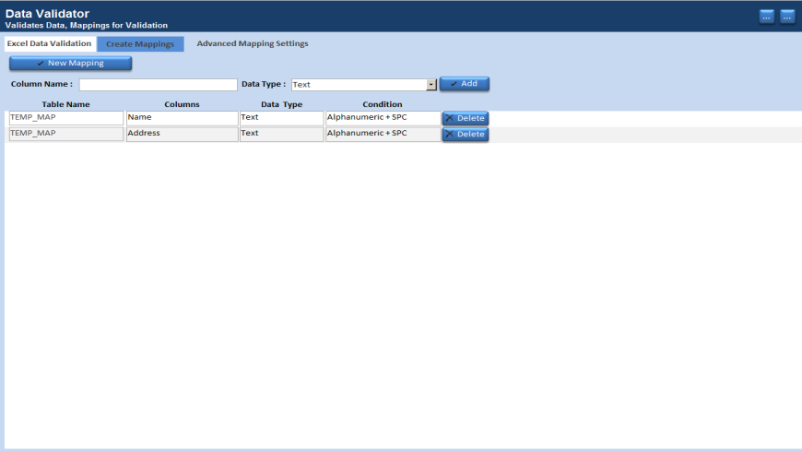**Create Mappings –** it**s** concern is to create a mapping matrix that matches to its source
3. **Advanced Mapping Settings –** Its functionality is to customize the condition of the data
   1. 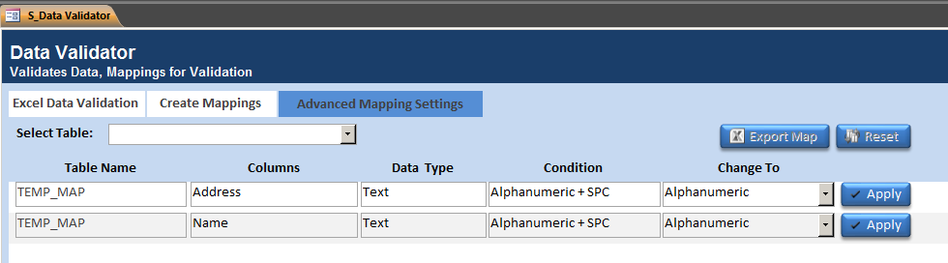Before
   2. 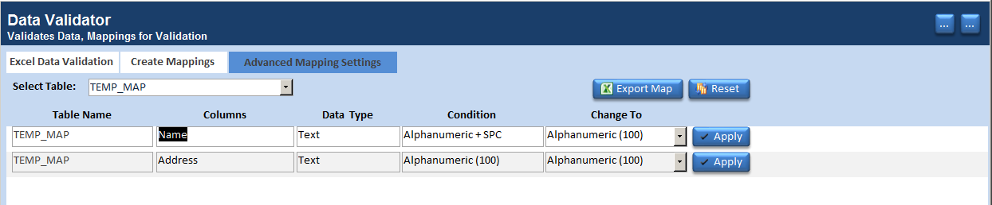After

**How to Use:**

1. Click *New Mapping* Button
   1. Under *Create Mappings* module, Match *Column name* to its corresponding *Column header* from its *source*.
   2. Declare *Data Type* (Boolean, Byte, Integer, Long, Currency, Single, Double, Date, Text, N/A) according to its *database table definitions*.

*Note: Each Data Type has own default condition. You can customize it on Advanced Mapping Settings.*

* 1. Click *Add* button

*Note: For some error inputs, you can use the Delete button to remove unnecessary mistakes.*

1. *Customize Mapping*
   1. Under *Advanced Mapping Settings,* you can change the condition according to its desired form.
   2. You can click *Export Map* Button and provide a destination folder. Otherwise, the export will be canceled.
   3. Now you can use the exported file as mappings to *Excel Data Validation* module
2. *Excel Data Validation*
   1. *Browse* for *Source* and *Map*.
   2. Click *Analyze* button.
   3. After Validating, you can export it by clicking *Export* button.

**Message Prompts and Solutions/Definitions**

1. *Excel Data Validation*
   1. *Source is required* – browse an excel type source file.
   2. *Map is required* – browse an excel type mappings file.
   3. *Map file is invalid* – browse a valid excel mappings file.
   4. *Number of errors: <n>* – you can export the error result by clicking export button
   5. *No Detected Errors. The source is valid* – it means that the validation has been completed without any errors.
   6. *Export Canceled* – the export has been canceled by user. You can click the export button again if you want to see the error result as an excel file.
   7. Successfully exported to <*Path>* – where path is the destination folder you have provided.